Chapter 3: Time Management
There are seven resources in this chapter:
- Student Weekly Schedule
- Warmup, Workout, Cool Down
- Class by Class Time Management Document
- Timeline for a Project or Paper
- Tasks and Checklist
- Thought Process Worksheet
- Finals Organization Document

Student Weekly Schedule
Below is an example of a typical student schedule. Note that the student schedules in class, lab, and homework time. They also schedule work, extra curriculars, and personal time. Be sure to include these in your schedule, also! Create your weekly schedule with the blank one below.
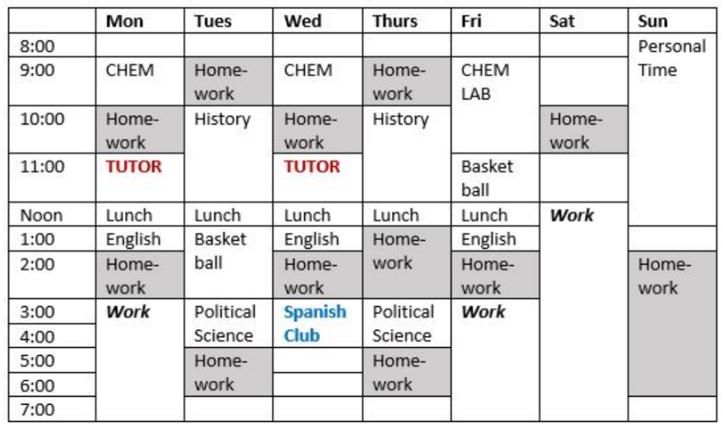

 | Mon | Tues | Wed | Thurs | Fri | Sat | Sun
8:00
9:00
10:00
11:00
Noon
1:00
2:00
3:00
4:00
5:00
6:00
7:00
8:00
9:00
10:00

Warmup, Workout, Cool Down
If you have ever played a sport, or been in a band, a choir or a play, you would likely agree that most practices and rehearsals have three distinct parts:
- A warm up to get the body, voice or instrument ready to work
- A Work Out which is designed to practice the exact things you need to do in a game, concert or play
- A Cool Down, which often has three purposes– one, to cool down the body and two, to evaluate that practice (for example a coach might tell the team what they did well and what they still need to work on) and three, to make a plan for the future based on how that practice went. (The coach might say, “Since we are doing well on this skill, we’ll focus our next practice on this other one)
Homework sessions can be like practices and rehearsals-- they can have a warm-up, a workout and a cool-down. The chart below defines warmups, workouts and cool-downs for studying and suggests activities that might be appropriate for your class. Read the chart and think about your classes. Make a study plan based on what you know about your tests and assignments. Give your study plan a try-- if it works, great. If it needs to be adjusted, use the suggestions below to select different study activities.

 | Description | Possible Activities
Warm ups | A home work session warm up’s purpose is to set goals for that specific homework session.  A warm up could take between 10 and 20 minutes. | - Review lecture notes to see what is confusing  - Page through a textbook chapter before reading it  - Review practice problems  - Re-read an assignment description  - Make a reading schedule  - Check D2L for updates
Work outs | During the workout, your job is to practice what you will have to do on an upcoming graded event– like a test, presentation or paper. If you have a class that involves taking tests over the reading, your workout will focus on reading.  The work out could take 30-90 minutes. | - Read and take notes on a textbook chapter or other reading.  - Write an essay, paper or report.  - Work problems.  - Write and practice a speech.  - Complete assignments.
Cool downs | The purpose of a cooldown is to do two things:  - Determine how well you learned the material you covered in the workout. During the cooldown, create conditions as close to the test as possible. For example, if you know you can only bring a calculator to your math test, spend your cool-down time doing problems just using one.  - Making a plan for future studying based on what went well and what was difficult or confusing  A cool down could take 10-30 minutes. | - Re-read an assignment description to make sure you completed it thoroughly and accurately.  - Answer review questions in a textbook to make sure you understood the reading.  - Summarize major concepts you read or learned by pretending you will be tested on them.  - Determine what was confusing and plan to resolve the confusion  - Generate a list of possible test questions  - Work a problem from start to finish with no help.

Class by Class Time Management Document
Get in the habit of sitting down at the same day and time each week to look through the D2L sites for each of your classes. Note what is due in the coming week, what you need to read and when major tasks, tests or papers are due. Complete the chart below for each class each week.

Week ___ Dates ______________________________________
Class:

Things I need to Read:  Reading:  Date Due  Reading:  Date Due:  Reading:  Date Due: | Major Due/ test/ quiz/ event dates:  Date:  What is due:  Date:  What is due:  Date:  What is due:
Number of hours I estimate I will need to complete the work for this course:

What days/ times will I study?

Are there study sessions or office hours to help me prepare? If so, when and where are they?

Timeline for a Project or a Paper
Completing a multi-week project can feel overwhelming! But if you break the project into smaller tasks, you can do each week, it seems less overwhelming. When you are done with a task, check it off so you can see your progress. You can customize this timeline in whatever way you want to. For example, if you have four weeks to complete your project, make a four-week chart to fill out.
The last three columns will help you be realistic about how much time the project will take you. In the “Estimated time” column, write down how many hours you think the task will take you. Once you complete it, write how many hours it actually took in the “actual time” column. Finally, when you have completed a task, write down the date you completed it.

Week ___
Dates | Tasks to complete | Estimated time | Actual Time | Date Completed
i.e. Nov. 27-Dec 3

Week ___
Dates | Tasks to complete | Estimated time | Actual Time | Date Completed

Week ___
Dates | Tasks to complete | Estimated time | Actual Time | Date Completed

Week ____
Dates | Tasks to complete | Estimate time | Actual time | Date Completed

Week _____
Dates | Tasks to complete | Estimate time | Actual time | Date Completed

Tasks and Checklist
If you have a project with multiple due dates, this chart might help you stay on track. List tasks you need to do to complete your project in the left column, then in the “estimated hours” column, guess how long it will take you to complete the task. Always be generous with your estimate; it’s better to add more time than not add enough. Then record when exactly you will do this work. Finally, write in each task’s due date. Cross off tasks once they are complete.
Task | Estimated hours to complete task | When I plan to do this task | Due Date!
Example: Outline for Essay | 2 | Monday from 6-7 PM and Wednesday from 9-10 PM | Thursday at Noon

Thought Process Worksheet

Name____________________________________

Class you are doing homework for ___________________________

Date__________________________

 | Questions to answer before I begin studying
Goal | What am I supposed to get done at this study session?  Why do I think my instructor is having me do this assignment?
Equipment  and skills | What equipment do I need to complete this work?  What skills do I need? (i.e. I need to know how to upload something to D2L)
Space | Do I have a place where I can focus?
Understanding | Do I understand what I’m supposed to do on this assignment?
Time | How long do I think this assignment will take me to do?
Continued on next page…

 | Questions to ask while I’m studying
Evaluate | Am I struggling with any part of this assignment?  If so, what can I do to help myself?  Is this assignment taking more time, less time, or about as much time as I thought it would?
 | Questions to answer after I’m done studying
Assess | Did I achieve my goal?
Time | Did this assignment take me less time, more time, or the amount of time I estimated?  How much time did it take?
Quality | Do I think I did a good job? Why or why not?
Reflect | How do I feel about this study session? What worked and what did not work?
Change | If I didn’t achieve my goals, what do I still need to do?  What should I do differently next time I study?

Finals Organization Document

In college, your schedule during finals week will be different than it is the rest of the year. As finals week gets closer, complete this document for each class for which you have a final.
Finals Week (Dates):_______________________________

Class:

Test date and time:

Testing place:

Final project/ homework due date:

Are there study session times or open office hours this week I can take advantage of? If so, when and where are they?

